|  |  |
| --- | --- |
| Logo_FPT_University_doc | **MINISTRY OF EDUCATION AND TRAINING** |

**FPT UNIVERSITY**

**CAPSTONE PROJECT DOCUMENT**

**Fstay**

**Report #1 – Introduction**

|  |  |
| --- | --- |
| **SWP490\_G7** | |
| **Group Member** | Phạm Minh Dương – SE05785 |
| Phạm Mạnh Đạt – SE05386 |
| Trần Đức Anh – SE06025 |
| Võ Đại Dương Phi – SE05784 |
| Lý Văn Thiên – SE05754 |
| **Supervisor** | Mr. Nguyễn Văn Sang |
| **Project Code** | Fstay |

- Hanoi, 05/2020 –

Table of Contents

[1 INTRODUCTION 3](#_Toc42010563)

[1.1 Purpose 3](#_Toc42010564)

[1.2 Acronyms and Definitions 3](#_Toc42010565)

[2 ABSTRACT 3](#_Toc42010566)

[3 LITERATURE REVIEW 4](#_Toc42010567)

[3.1 Airbnb.com 4](#_Toc42010568)

[3.1.1 Advantages 4](#_Toc42010569)

[3.1.2 Disadvantages 4](#_Toc42010570)

[3.2 Booking.com 5](#_Toc42010571)

[3.2.1 Advantages 5](#_Toc42010572)

[3.2.2 Disadvantages 5](#_Toc42010573)

[3.3 Luxstay.com 5](#_Toc42010574)

[3.3.1 Advantages 6](#_Toc42010575)

[3.3.2 Disadvantages 6](#_Toc42010576)

[4 PROPOSAL 6](#_Toc42010577)

[4.1 The idea 6](#_Toc42010578)

[4.2 Objectives 6](#_Toc42010579)

[4.3 Brief description about system 6](#_Toc42010580)

[4.4 System features 7](#_Toc42010581)

[4.4.1 General features: 7](#_Toc42010582)

[4.4.2 Web application features: 7](#_Toc42010583)

[5 BENEFIT FROM PROJECT 7](#_Toc42010584)

[5.1 For our group 7](#_Toc42010585)

[5.2 For Community 7](#_Toc42010586)

[6 CRITICAL ASSUMPTION AND CONSTRAINTS 8](#_Toc42010587)

[7 POTENTIAL RISKS 8](#_Toc42010588)

[8 REFERENCES 9](#_Toc42010589)

# INTRODUCTION

## Purpose

This document is prepared as the introduction for project Fstay, in scope of Capstone Project at FPT University. It is included the overview of some existing systems, the initial idea of this project, a brief description about our expected system and some potential risks, critical assumptions, constraints,…

## Acronyms and Definitions

|  |  |  |
| --- | --- | --- |
| Acronym & Abbreviation | Definition | Note |
| SQL | Structure Query Language |  |

Table 1-1: Definitions and Acronyms

# ABSTRACT

Homestay is the term for a type of accommodation that is quite popular today. It is a type of tourism that tourists will stay and sleep at local people’s home, where they come to help tourists discover, experience and learn the customs, cultural life of each region in that locality.

Understand the simplest and most comprehensive way, homestay is a form of community-based tourism, staying in a homestay, the locality where visitors come, helping it promote the culture, people and beautiful scenery in a real way. The type of homestay is especially suitable for multicultural countries like Vietnam, most developed in tourism development provinces and cities such as Hanoi, Yen Bai, Moc Chau, Hue, Da Nang, Hoi An, Da Lat, Ben Tre, Long An, etc.

According to research, most homestays are often formed and developed in areas with wild resources to be preserved, residential areas with diverse cultural resources, rich cultural characteristics, ethnic groups, areas that do not qualify (funding, scale, planning, ...) to build motels, hotels or restaurants, cafes to serve the needs of tourists.

In order to run a homestay business, households will renovate their own homes to meet the essential requirements, then apply for a business license at the local government and start welcoming guests. Accordingly, usually, each family can welcome from 10 to 30 visitors (depending on the scale) with prices ranging from a few dozens to a few hundred thousand per room. Although it only stops at an average level, the services at homestay are quite complete, serving personal needs such as eating, resting in a comfortable and pleasant way with the best price.

As all benefits and characteristics of homestay, we want to develop a website for renting homestay. The product is a website run successfully on web and support renters in making decision to find out their interest homestay. Moreover, the website can display location on map and have easy to use payment system through the need of travel nowadays.

# LITERATURE REVIEW

Currently, there are so many websites about homestay that help users looking for places, find out not only homestay information, but also information of other type of house for renting. In order to have the most intuitive view, we list three popular websites currently in both the world and Vietnam: airbnb.com, booking.com, luxstay.com; and figure out the advantages and disadvantage of these websites.

## Airbnb.com

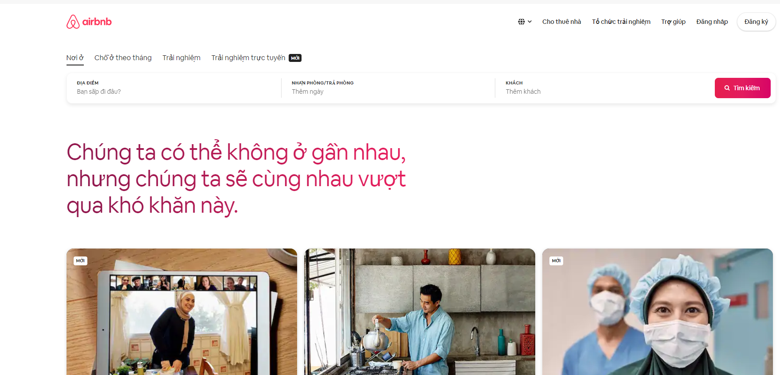

### Advantages

- User interface is very nice and easy to use.

- Support many functions.

- Quick response for user’s action.

- Can export map in many formats.

### Disadvantages

- Don’t support for many places in Vietnam.

- High cost for Vietnamese.

## Booking.com

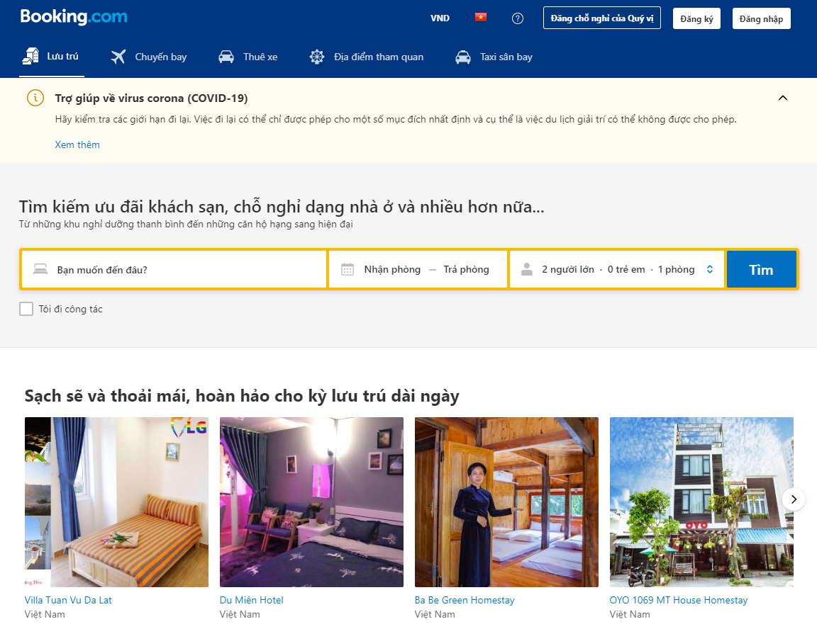

### Advantages

- Support many functions.

- Quick response for user’s action.

- Can export map in many formats.

### Disadvantages

- The interface is confusing for users.

- Too many ads.

## Luxstay.com

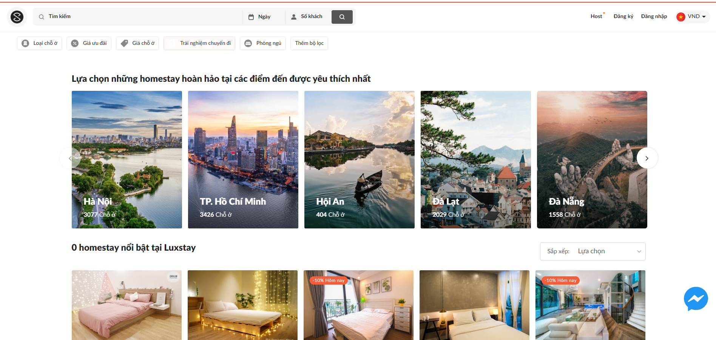

### Advantages

- User interface is very nice and easy to use.

- Support many functions.

- Quick response for user’s action.

- Can share to social networks such as Facebook, Google etc.

### Disadvantages

- Booking homestay without prepaid that makes owner has too many fake orders.

# PROPOSAL

## The idea

The idea of creating a website for homestay renting is not new; there are many existing websites share this idea now. However, our expected Fstay website is included some main functions of current websites and add to some special features such as intuitive interface, Vietnamese language supporting, ease to use. Therefore, the project group aims at bringing a better, faster and easier website that suitable for a very active homestay service in Vietnam.

## Objectives

This project is the Capstone Project for all team members.

Firstly, we do this project to fulfill the requirements from FPT University studying program. During the time do this, we can learn how to develop a project, how to communicate with other team members, how to control time, how to do teamwork effectively. We also can work with some new technology such as Java framework – Spring Boot, JS framework - Angular. Therefore, after finishing this project, we can practice what we have learnt in university and learn so many new things. It is very necessary for our future work after graduating from FPT University.

Secondly, we want to create a website for homestay renting that helps users, especially Vietnamese users, to fulfill their need easily. Our objective is to make a better website in this field – homestay.

## Brief description about system

This website has only one versions for web. With friendly interface, user can easily find out what they want with or without registration. It also displays the appropriate homestay that have similar uses with searched one. Therefore, user can reference to make the best choice for themselves. In addition, with homestay management function, our software can bring the best trustful homestay to users. It is also useful when users are staying at strange location and need to find out the rout to the nearest homestay.

## System features

### General features:

* Search homestay.
* Find homestay location on map.

### Web application features:

* Advanced search by location, name, room’s type, number of beds, guests.
* Provide management feature for owner to create, update and delete their homestay.
* Admin management: exchange money between renters and owners, accept or reject owner’s creation.

# BENEFIT FROM PROJECT

If this project is developed and implemented successfully, our group and user community will get some benefits from it.

## For our group

After developing and implementing this project, our group will get some benefits:

* We have more experiences of managing a software project: how to manage plan, time, and risk. These experiences help us a lot in our future work.
* Know how to communicate with other team members and how to do teamwork efficiently.
* Have a chance to study and understand new technology like Spring Boot, Angular.
* Know more about the business of how an order is set and check out, method of payment.
* If this application is developed, we will get a good mark in Capstone Project. It makes our grade better.

## For Community

After developing and sending Fstay, users can get many benefits from it:

* For renters:
  + Have an overview about typical type of homestay.
  + Can search homestay by interest and needs easily.
  + Have guarantee for trustful homestay.
  + Save their homestay order schedule.
  + Many promotions included.
* For owners:
  + Can promote homestay widely.
  + Attract many renters.
  + Manage list orders easily.

# CRITICAL ASSUMPTION AND CONSTRAINTS

There are some critical assumptions that we realize after analyzing this project. The first assumption is about team members. We assume that all the developers can study coding technique and knowledge in a short time. We do not know much about Spring Boot and Angular before this project, but we have to study hard for not missing any deadline of project plan. Besides, we also assume all our members do not have any health problems, so they are not absent and can do their works.

There are also some constraints of our project. Firstly, about the time and deadline, we have to finish project on time. It has no extra time for us to complete developing and deliver product to teachers. Besides, the reports need to submit before the deadline. Secondly, about the quality, our website must be well enough for users to do main functions with their needs. Finally, with all the expected features that we gave before, we do not know if we can solve all of those or not. However, we will try our best to make our project successfully.

# POTENTIAL RISKS

After studying about this project, we find out some problem that we may encounter:

* We do not have much experience in exchange information, managing and controlling work so we might be missed the deadline or out of scope.
* We have not much knowledge in the framework and technique (Spring Boot, JPA, JDBC, Angular 9, etc). Therefore, we have to study all of these things from the beginning. This work takes lot of times. The project team may face with the difficult technical problems that may requires long time to resolve so that causes the project be delayed.
* We find it is hard in collecting data for data source and studying the business about payment method. If we misunderstand something, we might develop the system in the wrong way.
* In addition, we also have difficulty in using some tools such as Microsoft Project, Eclipse, MSSQL Server, source code management … Therefore, our work management may be not good.
* Sometime, because of careless, team members can lose data, source code… before uploading to server.
* We do not have any experiences in software project management such as time management, risk management etc. Therefore, our project plan will be not good and completed. So maybe we will miss the deadline or have some unknown risks.
* It is the first time we manage big project like this, we do not have much experiences in communicating between the team. So maybe in the future, we will have conflict and argument and we will not finish all the works in time.

# REFERENCES

[1] Airbnb: <https://www.airbnb.com.vn/> viewed May 31, 2020

[2] Booking: <https://www.booking.com> viewed May 31, 2020

[3] Luxstay: <https://www.luxstay.com/vi/s/> viewed May 31, 2020